Dear David

Recently I spoke to Todd Dickinson to request assistance in facilitating a Plan of Management for Catherine Park and its catchment. We agreed that to resolve issues impacting the park and surrounds it was important to have stakeholder cooperation and communication. As suggested I will be including Todd, John Heptonstall, Steve Lawler and Steve Watson in this and future emails where relevant.

Following my conversation with Todd I was pleased to receive a phone call from Steve Lawler. Steve acknowledged our concerns for a management plan, but indicated with present commitments there would be a wait of 6 months. In the short term he would speak to:
- Todd Dickinson regarding the opportunity for contract work for the bushland surrounding the park;
- David Munday regarding the restoration of the waterfront and pedestrian access from Catherine Park, Kindy, playground to Tennis Wharf and Pittview Street (see notes below)

Our Subcommittee met again, March 20th, to discuss upcoming works and present issues. Enclosed is an update from the most recent meetings of our Roads, Drainage and Environment Subcommittee

Upcoming works – Comments and Concerns
General Construction
It was noted that the stated road width for sealing was 3.5 meters. We request that Council follow the guidelines of the Recommended Traffic Management System, an outcome of community consultation, as stated in the Draft Road Reserve Strategy 2009, reference page 39 and 40.
- All roads designated as shareways subject to RTA approval;
- One share lane accommodating 2 lane traffic;
- Typical carriageway of 3 metre width;
- Traffic volumes contained by restriction on number of private vehicles by some form of licensing;
- Shareway signage and road markings implemented in consultation with the community
- Encourage use of island vehicle
Water bars - recommendations
- Frequent use of water bars to control stormwater flow and flush drainage lines, most helpful during the first flush and critical at the top of sealed road sections and prior to pits.
- Water bar designed and constructed with a gradual rise and fall to facilitate safe crossing by vehicles

Kevin Avenue – Restoration with improvements to sealed surface, drainage lines and road verge
Our Subcommittee is anticipating that each of the issues mentioned in previous communications has or will be addressed or investigated:
- Use of detailed design especially regarding width of road, road camber, depot, water bars, drainage lines and pits
- Consultation with immediate residents regarding any formalisation of the works depot
- Restoration of the road verge with local native plants to stop erosion and bank collapse
- Log edging replaced/added to manage vehicles movements, Thompson Street, Kevin Avenue to Florence Terrace
- Cement channel with subsurface drainage, Thompson Street to Florence Terrace
- Evaluation of the rock lining in the outflow from the drain at Kevin Avenue and Florence Terrace
- Resident access points and driveway stormwater flows, especially Thompson Street chainage 0
- Stormwater flow from Thompson Street chainage 0-100 and from Kevin Avenue chainage 100 to prevent stormwater damage to any new works

Catherine Park pedestrian access to/from Tennis Wharf to Playground, Kindy and Community Hall
The stonework at the access point was rebuilt by the community in 2002 with stones supplied by Council. Despite bollards being put in place it has become increasing popular for unregistered buggy and quad bike owners to drive along the waterfront of the park to access the park and Kindy.

SIRA supports Council in its efforts and acknowledges the need to provide safe access and recreation along the waterfront. Our Subcommittee met to discuss the existing proposal for community comment and agree that this is a one-off opportunity to save and restore the waterfront to recreational use while still providing access for those with mobility permits.

We support:
- Designated short term parking below the fireshed with log edging
- Minimum signage as required in consultation with the community to facilitate enforcement
- Parking for vehicles with a current RMS mobility permit at the entrance to Catherine Park between the stonewall and the stone steps
- Placement of bollards limiting access to the walkway at the end of the parking area just past the steps to prevent continuing encroachment into the park and picnic area.

Minimalist turning for vehicles is a topic of on-going discussion. Mobility scooters turn in a confined space, but buggy turning is more difficult. Options are:
- to provide turning on the adjacent beach, around the iron bark tree at the entrance, OR
- at the space between the stone steps and the next stone wall.

Our Subcommittee and community is committed to the restoration of the waterfront as a beautiful Gateway to the Island, to the preservation of the ironbark tree and surrounding stonework and resident seating. We also acknowledge the need for mobility parking, but we require additional input to achieve the best outcome, especially regarding the ‘turning loop’ and options for restoration.

We request that following the period of consultation and prior to any works being undertaken, that there is an onsite meeting with the appropriate Council officers and SIRA representatives to discuss the options.

Vehicle Management – A Shared Vision
2018 an opportunity to work together for the restoration of Kevin Avenue and Catherine Park

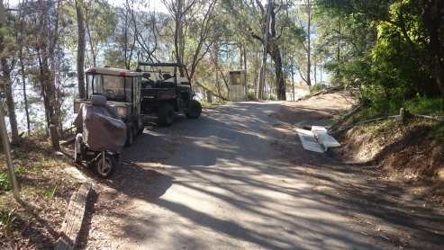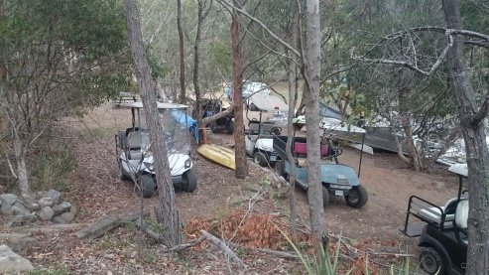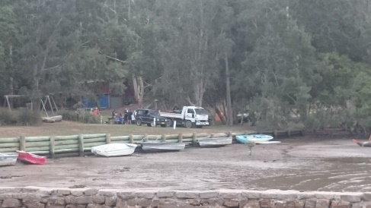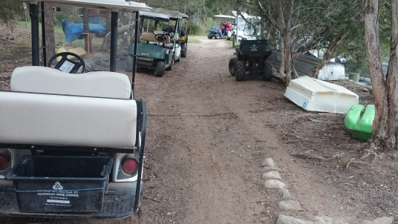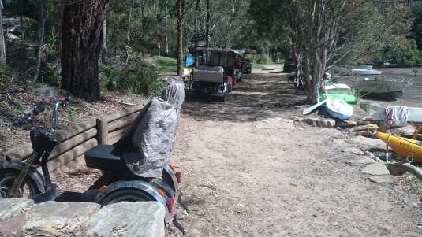
Unmanaged access to the Park and adjacent roads – A safety and environmental concern

Mobility vehicle parked in potential parking area
Illustrates the recommended space to steps as adequate

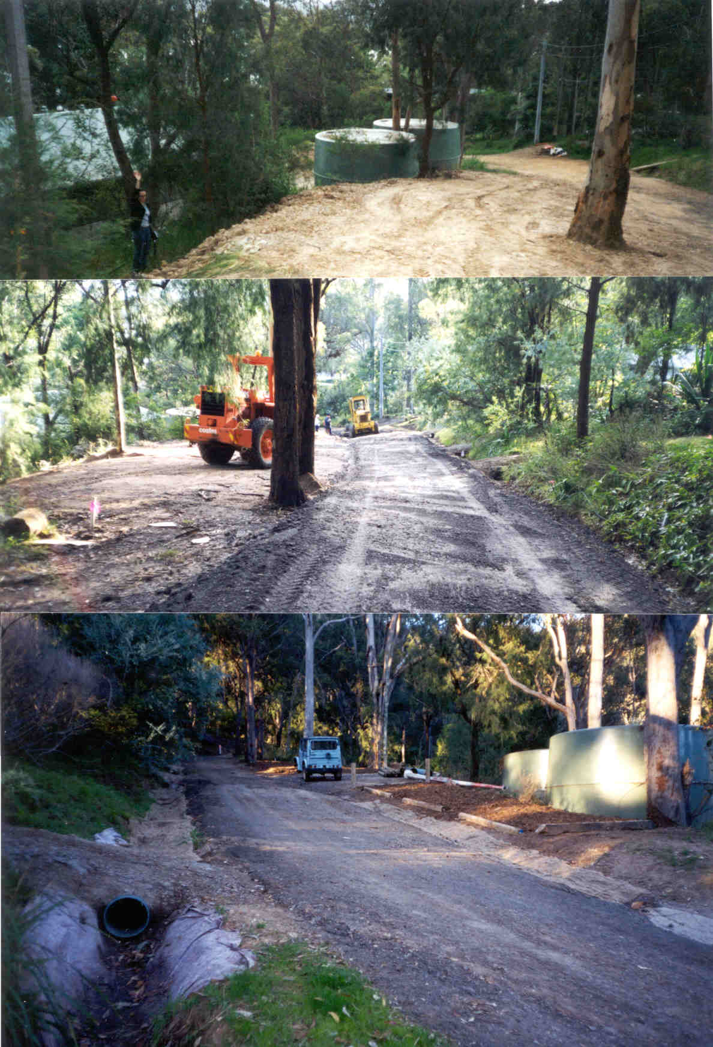
Outcomes Stormwater Trust Grant 2002
- Showing defined road edge, jute lined drain,
- Restored and defined verge

Prior to the use of park and road reserve as a depot, loss of 5 mature trees and infilling of drains with gravel

Depot site 2018 – intersection of Thompson and Kevin Ave
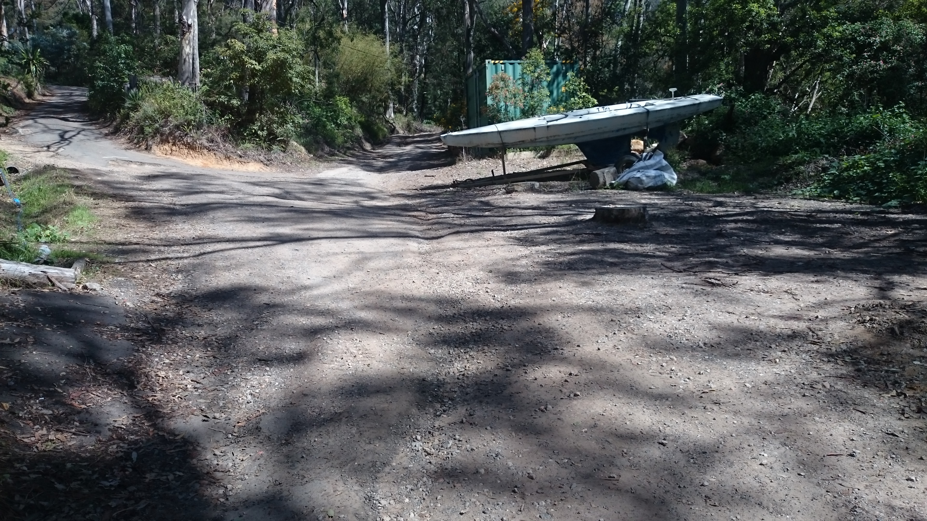
Additional issues discussed:

Catherine Park:
- Removal of accumulated debris from branches and trees cleared from park and pedestrian access and deposited in the garden beds and surrounding bushland
- Restoration of the swale drainage and outlet to the bay
- Restoration of the play surface in the park
- Follow up with Todd Dickinson and Steve Lawler to facilitate a Plan of Management for Catherine Park

Road and Drainage Issues and Concerns
- Need for regular maintenance of all water bars and drainage lines
- Consider ‘Adopt a Drain and Road Verge’ to engage local residents
- Deterioration of access road/firetrail to homes at the top of Island, especially at the intersection
- Potential closure to all service vehicles i.e. recycling and Community Vehicle
- Need to complete and an inventory of all walking tracks on Scotland Island to support maintenance
- Grant for the restoration of Lower Elsie track is complete, however, additional funding is needed to stabilise the side drainage channel
- Need for a follow up plan for the spraying of road edges to prevent erosion of the road verge and widening the surface by vehicle traffic. Option Supply plants to residents as ‘Adopt a Verge”
- Access to copies of digital maps to facilitate better recording and communication with Council
- Placement of all relevant plans and studies on the Council website

Steps Middle Elsie Street
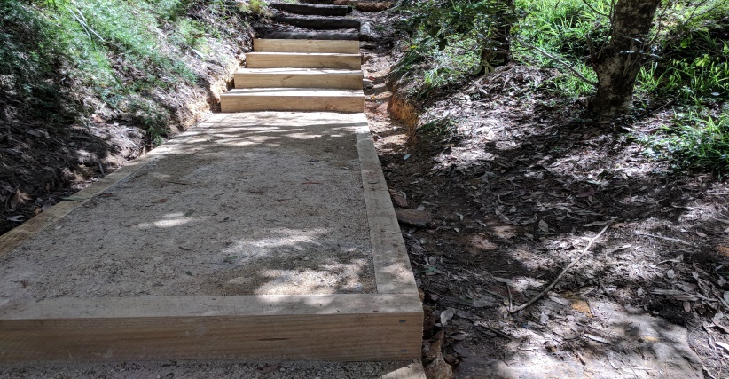
Fire Trail to the top of the island
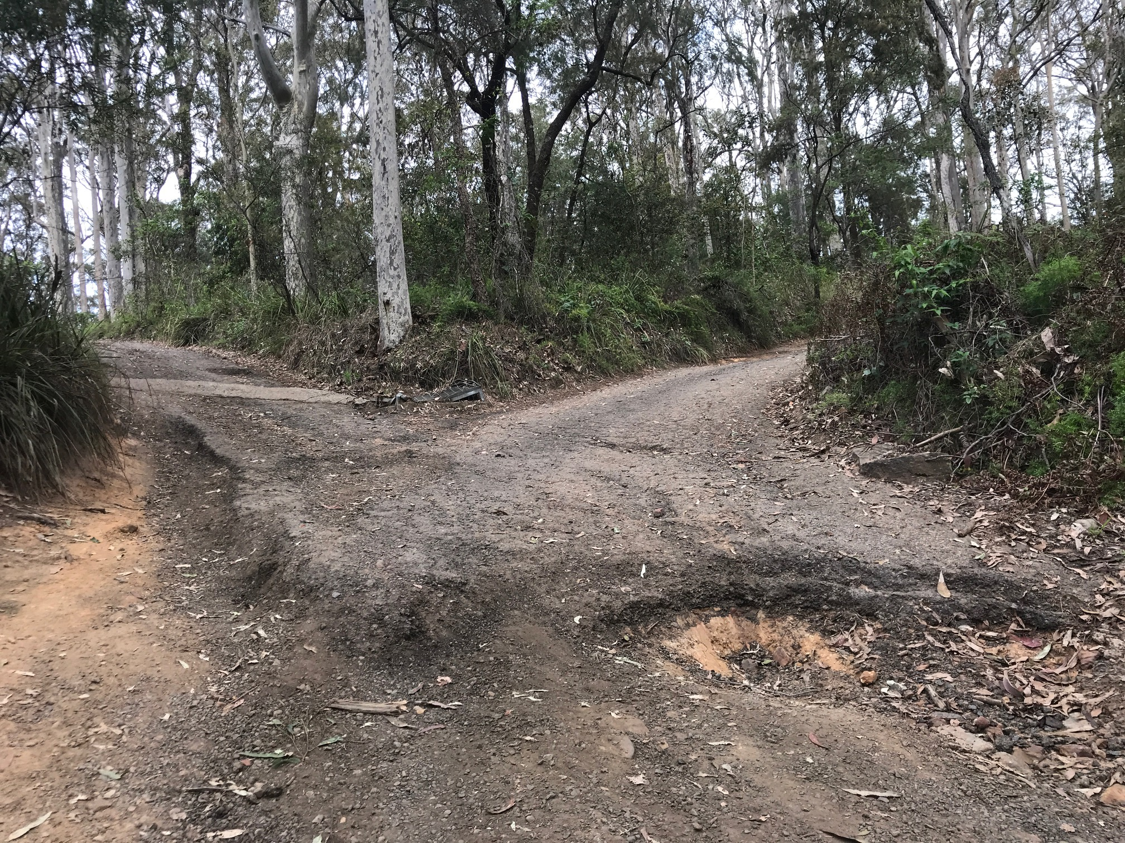

In summary, the residents of Scotland Island are committed to working with Council and appreciate the efforts by Council officers to collaborate for continued improvement to our roads, drainage and the environment. We note the items discussed are compatible with the Road Reserve Strategy and the goals of our subcommittee as stated in the SIRA Welcome Booklet 2018, presented to Councillors

With the upcoming works we would appreciate your continued communication with our Subcommittee regarding design and implementation for a positive and cost-effective outcome. We look forward to your reply to our concerns

Welcome booklet enclosed providing background and goals of the SIRA subcommittees published March 2018 to assist Councillors and others in understanding the issues and needs of the Island Community

