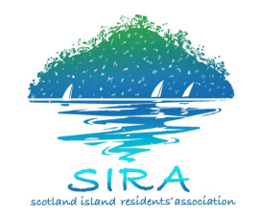
SIRA Committee Meeting – Community Hall
Sunday, 21 February 10:00am - 12:00pm

AGENDA
Coffee/tea station open prior to and throughout the meeting (no prescribed coffee/tea break).
Agenda Items | Time | Finish Time
Chair: Colin Haskell, President  Acknowledgement of Country and Welcome  Apologies  Election of Time Keeper | 10:00am | 10:15am
SIRAC BUSINESS  President’s Report  - (5 minutes Question time - an extension of 3 mins is available)  Treasurer’s Report  - SIRA Management Accounts and Treasurer’s Report –  Secretarys report  - New committee list  Working Group Reports  Water Waste Water –  - meeting with the minister Colin Haskell  - Pump update  Roads/ Traffic Management  - Proposed council closure of a section of the ‘fire trail’ on the north east side of the island; the section that goes up to 44-50 Thompson Street (does a loop down a hill and comes back up).  - Gazetting of the fire trail to be a road: in spite of repeated requests, no information has been forthcoming from Council about this development  - Traffic Management plan. Buggies and vehicles. – Cap on transportation, licencing and registration  - Traffic plan of management implementation contested byAction group – Ben Dray Community Vehicle Transport  - bollards  Communications  - Sira & Pon  - Newcomers  - Website directory  - Community representation  Events and Community Engagement  - Café  - Purchase of a new barbeque  - Other upcoming events  Kindy/Hall  - Update on kindy  - Old Sira paperwork  - New hall manager  Waste Management  Wharves  - Carols progress, commuter wharf etc  Strategy and Vision | 10:15am | 11:30am
GENERAL BUSINESS – all members are invited to contribute  1.. Pasadena  2. proposed rate changes – Alec Beckett  Please notify the secretary in writing by COB Friday, 19 Feb of any items to be listed for general business (including motions to be brought) secretary@sira.org.au  Additional items, raised at the meeting, will only be considered for discussion if time permits | 11:30am | 12:00 noon

