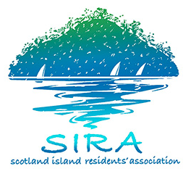

Scotland Island Residents Association invites applications of interest for the position of Accountant for a three year period commencing from
August 4, 2020.

Once every three years SIRA is required to open the paid position of Accountant to Expressions of Interest. The current three year tenure expires this year. SIRA invites applications of interest for the position. The allotted paid time for the Accountant is two working days per month at a rate set by the committee. The current approved rate is $45 per hour. The tender process is competitive, but not on the basis of pay rate or paid hours per month.

The accounting requirements of SIRA are quite complex. The Emergency Water activities generate around $100,000 in turnover per year. There is quarterly reporting and invoicing related to the Community Vehicle. The Community Hall requires an invoicing and accounts receivable function. The Accountant supports the creation of a sophisticated budget, and there is a monthly budget reporting system with detail down to activities and cost centres. The Accountant supports the creation of funding applications, funding reports and acquittals. There have been three major funded projects in the last two years, worth in excess of $60,000. It is anticipated that the Accountant should attend SIRA meetings as required, and to provide information to the various subcommittees on request.

Bookkeeping/Audit qualifications from applicants are essential for this position.
The role includes the following duties:
- carrying out bookkeeping tasks ,bank reconciliations, accounts payable and receivable;
- producing monthly management accounts;
- preparing special and ad hoc reports on request;
- preparing and lodging BAS report;
- assisting Treasurer with SIRA’s Annual Report.
The Accountant works closely with and reports to SIRA Treasurer

Applications should be made to the SIRA President by email at president@sira.org,au by no later than 15th of June, 2020.

Details of terms and conditions of employment for this role will be discussed once applications have been received.

If you require further information on this position please email secretary@sira.org.au

