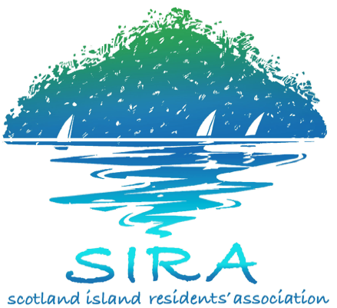
Scotland Island Residents’ Association

Minutes of Committee Meeting

Date: October 9th, 2016
Venue: Community Hall
Present: Bill Gye, Judy Readman, Hubert van Mierlo, Boyd Attewell, Marie Minslow, Iza Foster, Cass Gye, Sharon Kinnison
Apology: Roy Baker, Emmie Collins, Eileen O’Conner, Karen Warburton, Paul Kinnison, Ray de Smeth, Skip Miller
Observers: Robyn Laughton Smith, Graeme Crayford
Opening: Meeting opened at 10:10 a.m.

Item | Title | Tabled Documents / Actions
 | PREVIOUS MINUTES
 | Confirmation of Previous Minutes – Meeting Approved  HvM Proposal to organise meeting with the Ranger - agreed | HvM to organise
 | CORRESPONENCE
- Letter from Jan Tinkler regarding flyer on offshore
- Letter from SIRFB request for donation
 | TREASURER’S REPORT
 | - Hall income has improved.  - Draft annual report is completed. Boyd to circulate the draft. | Circulate draft annual report.
 | GOVERNANCE
AGM – 13 November – time 10 for 10:30
- Sausage sizzle provided by SIRA
- Simply voting, make sure that returning officer is briefed. Ask Ian White.
- SIRA supplies champagne (already in stock) and sausages – Cass + Sharon.
- No door prize.
- Motion to be put forward: life membership for Cass and Bill.
- Nominations process the same as last time.
Roles and responsibilities: Documents to be put forward to next committee as a working document, also include in documents for nominations.
 | CHURCH POINT
- Include notes from SIRA/WPCA meeting
- Do we need to include point 3 – who can buy permit.
- Pasadena DA – council will make their assessment. Submissions can still be made.
- During construction there needs to be signage to indicate the offshore parking-on/offload area.
 | SIRFB Donation
- Graeme Crayford addressed the meeting. CFU was introduced 2 years ago. There is only one CFU box in place. SIRFB would like to add 2 boxes and is looking for funding. They have their own $3,000 funding and are short $2,000.
- HvM Motion: That SIRA donates $2,000. Seconded by Judy Readman. Motion adopted.
 | REPORT ON NATURAL ENVIRONMENT
- Verbal report from Emmie Collins.
- BG: two applications for community partnership grants, we will know the outcome in December.
 | PROPOSAL TO INVESTIGATE AUTOMATED WATER BOOKING SYSTEM
 | - Water system – implementation – agreed to proceed with discussion with water monitors and testing .
 | SIRA MEMBER SURVEY 2016
- Final survey contents agreed.
- 48 hours to provide feedback
- Let it run for 2 weeks, make
 | SIOCS MATTERS
 | - No reports received from the SIOCS committee, so no decision can be made at this point for a further tranche of the loan.
 | OTHER MATTERS
 | - Council Reference groups, are there

Meeting finished 12:30
ROLLING TASK LIST
Task/topic | Group or person responsible | Initiation date | Last Update
Second Survey Church Point | Bill Gye | March 20, 2015 | CP working group
Elsie Steps Completion, BG to talk to PB and EC | Bill Gye | July 17th, 2016
Installation of data projector | Boyd Attewell | March 20, 2015 | Complete
Receive and review SIOCS finance reports, report to committee | Boyd Attewell | July 17th, 2016 | WIP
Water monitors appointment and inductions | Boyd Attewell, Cass Gye | July 17th, 2016 | Done
Issues surrounding Cargo Beach usage etc. | Cargo Users Group (HvM / JR) | June 05, 2016
Pasadena DA, further communications, protest to be scheduled for the 11th of September | CP working group | Aug 28, 2016 | 211 Submissions
Review remuneration policy Hall | Finance Working Group | July 17th, 2016
Look for renewable energy provider for Hall | Hall Working Group | June 05, 2016 | Done
Harold Reserve issue: Follow up issue of pathway to Carols Wharf with PWC. Circulate community update note. | Parks, Reserves, Wharves and Marine | June 29, 2014 | Held over 24/01/2015
Provide updated Tree Preservation Policy for website to replace outdated information | Parks, Reserves, Wharves and Marine | Nov 2, 2014 | Held over 24/01/2015
Create a proposal for dog management, including an off-leash area and provision of dog poo bags | Parks, Reserves, Wharves and Marine | Jan 18, 2015 | Held over 24/01/2015
Proposal to make island a cat-free zone | Parks, Reserves, Wharves and Marine | Jan 18, 2015 | Held over 24/01/2015
Discuss issue of buggies in the park | Parks, Reserves, Wharves and Marine | Jan 18, 2015 | Held over 24/01/2015
Discuss and potentially suggest a new name for this group | Parks, Reserves, Wharves and Marine | March 08, 2015 | Held over 24/01/2015
Discussion with TUG | Committee | October 09, 2016

